Logie Kirk News
Winter Edition 2018
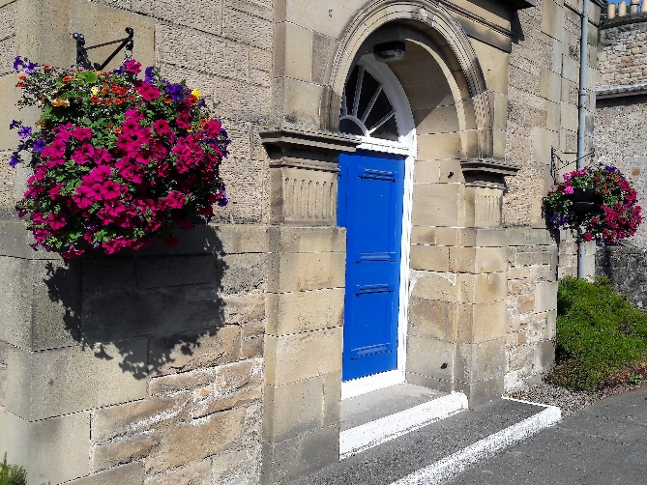

Keep up to date with all the news at Logie

Logie Kirk Stirling
Church of Scotland
Charity No. SC001298

Dear friends,
It is now just over a year since
I first arrived with you and what a wonderful year!

It has been so good to get to know the people of Logie Kirk in worship and in conversations of many different kinds from the chat at our coffee mornings to formal meetings of the Kirk Session. Many words have been shared among us in this first year together.

As Christmas approaches it is good to remember what the Bible says about words. In the creation stories of Genesis God’s Word spoke everything into existence. God said “Let there be light! “God said “let there be stars and plants and animals, fish and birds” God said “let there be people in our likeness to look after the earth”. God spoke all things into being and continues to create through God’s Word.

Jesus Christ is described as the Word of God. John’s gospel, starts like this: “In the beginning the Word already existed; the Word was with God, and the Word was God” and it goes on “the Word became a human being and, full of grace and truth, lived among us”

Jesus expresses God, not in a speech bubble but as a human being. On that first Christmas, the Word of God took human shape, and his name was Jesus. How wonderful is that! I hope you will enjoy all your Christmas conversations and in them remember the wonder of Jesus Christ, the Word of God.

The Waiting

(based on a Wild Goose Resource Group meditation)

When the time was right God spoke
and the light slipped through
When the time was right God drew breath
and the Word was delivered
When the time was right God hesitated
as the Son fell from heaven to earth
When the time was right God cried
as the Saviour was given to redeem the world
When the time was right God knew
this was the moment of birth
And when there was no more time God laboured
and the time was fulfilled
Now justice is born
be it so

May the peace of the Word of God be with you all this Christmas,

Rev Ruth Halley (Minister of Logie Kirk)

The next issue of Logie Kirk News to be published in January will be a special edition to launch the development project Looking Forward
Debate on the Impact of Climate Change

The Friends of Logie Kirk and the University of Stirling held the 4th in their series of biennial debates on Wednesday 7 November on the topic “Do we have a moral responsibility to save the planet?”

Professor Malcolm MacLeod, the Senior Deputy Principal at the University introduced an impressive line-up of speakers. The event was chaired by Professor Maggie Cusack, the Dean of the Faculty of Natural Sciences at the University.
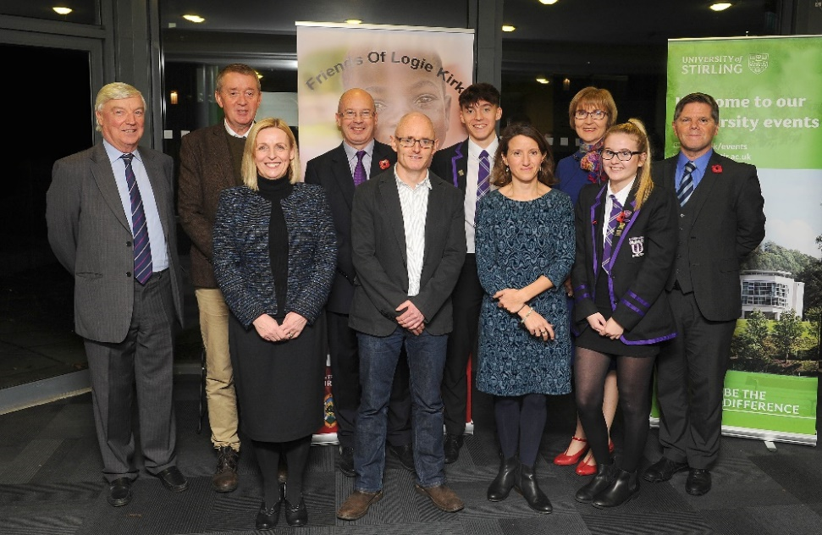

(left to right) Ian Lumsden (Secretary to the Trustees of the Friends), Adrian Shaw, Rev Ruth Halley, Professor Malcolm MacLeod, Alastair Jump, Dr Daisy Dent, Professor Maggie Cusack, and Adrian Valenti with students from Wallace High School who helped at the event.
The key note speaker was Martin Valenti, the strategic director of the Scottish Land Commission, who argued that although the problem was a major one, we should not approach it from a position of fear and blame but rather from cooperation and optimism. As he said “fear paralyses, optimism mobilises “.

The other speakers were Adrian Shaw, the climate change officer for the Church of Scotland, Professor Alistair Jump, Professor in Biological and Environmental Sciences at the University and Dr Daisy Dent, Research Associate at the Smithsonian Tropical Research Institute in Panama, who brought out different social, political, theological and ethical aspects of the whole question.

There followed a lively debate on questions raised by the large audience and the successful evening was ended with a vote of thanks from Rev Ruth Halley, the minister, and a Trustee of the Friends of Logie Kirk.

0000000000000000000000000000000000000000000000000000000000000000000000000000000000000

SocialBite’s Sleep in the Park

A small but enthusiastic team of Logie Kirk’s finest are ready for the challenge to help homelessness as part of Social Bite's "SLEEP IN THE PARK" challenge on 8th of December 2018.

Our team includes Jim, Ebenezer, Megan, William & Alex, who would be grateful for any donations, please give generously for this worthwhile charity.
Sleep In The Park is a nationwide Sleep Out to end Homelessness in Scotland for good.
4 Cities, 12,000 people under the Stars.

www.sleepinthepark.co.uk Donations can be made on line at https://uk.virginmoneygiving.com/Team/team-logie or handed to any elder.
Pastoral Care
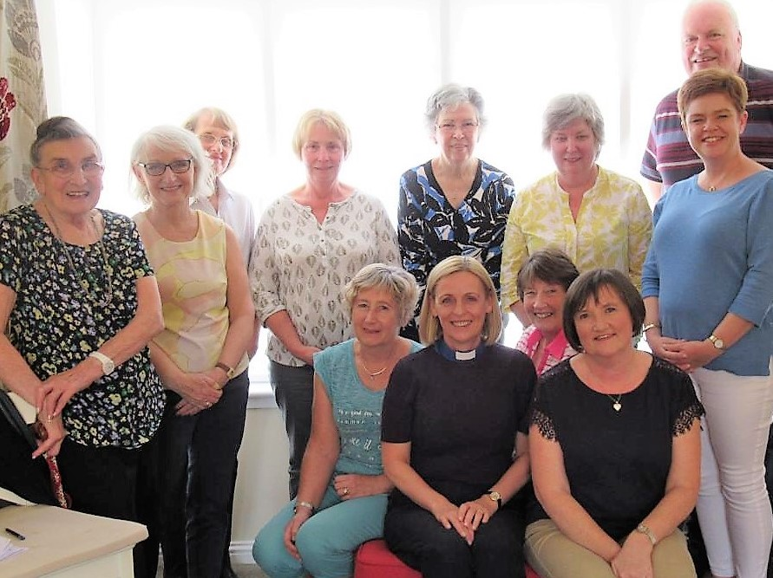
Pastoral care is an essential part of Christ’s calling to the Church. At Logie we have a group of 13 who work alongside the Minister and District Elders to help with this. The Pastoral Care Team gathered together for the first time in March to agree a joined up approach to try and ensure that no one is missed who needs our support, whether that be someone who is unable to attend church, is sick or in hospital, or would simply appreciate a visit.

Standing are: Elise Sharpe, Carolyn Stones, Audrey McKerracher, Fiona McBride, Senga Campbell, Brenda Smith, Alison Gow and Peter Gilmour. Seated are: Helen Eadie, Rev Ruth Halley, Linda Liddle and Dianne McNaughton (PVT Coordinator)
If you know of someone who would like a visit, or if you would like to join the team as a visitor, please contact Rev Ruth Halley by email or note, or Dianne McNaughton on 01786 478238 or by email eilidh08@sky.com.
The Donald Inglis Quaich

At Muthill Golf Club on Sunday 30 September, 8 golfers participated in the competition in order to be crowned the 2018 winner of the Donald Inglis Quaich. After 3-4 hours of competitive golf played in beautiful autumnal weather, the victor was announced, Alan McGregor, son-in-law of Betty and Donald Inglis, a fitting winner. The minor placings were filled by Ricky Cassidy and Craik Taylor. Both the nearest-the -hole and longest drive competitions were won by Terry Green.
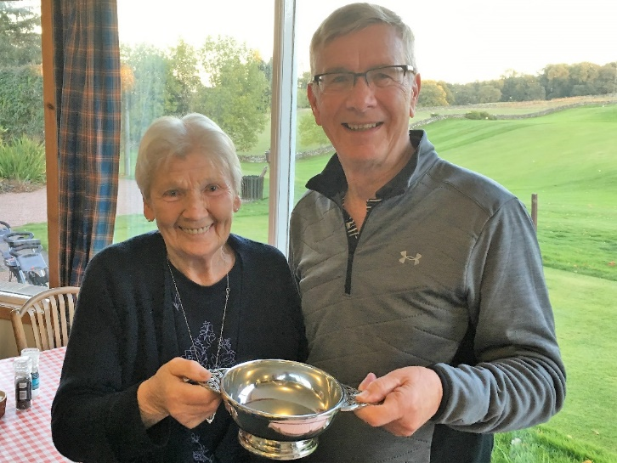
The prizes were presented by Betty Inglis who also, very kindly, donated them. This was, in fact, the sixteenth playing for the Quaich, a tradition stretching back to 2002, when Betty presented the Quaich to the golf society in memory of Donald.
It is tribute to Donald’s memory and Betty’s unwavering support that, some 16 years on, the Quaich is still being as fiercely fought over as ever.
In fact, we are now playing for a new Quaich as the original one has no more space on which to engrave the names of any future winners. The original was handed over to Betty which ensures that it remains in Donald’s family in perpetuity. Thank you to all who came along, to Muthill for providing a fitting venue, and the Inglis family for all of their support.

Ricky Cassidy
The Telford Family
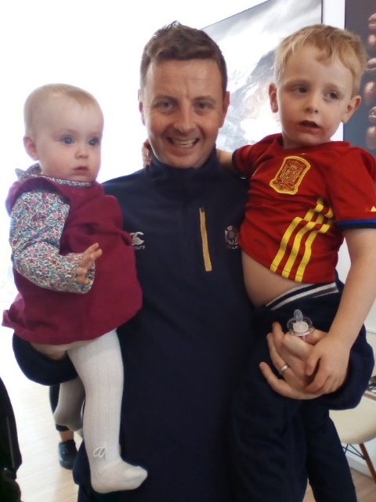
Many of the congregation will remember David and Lynsey Telford who travelled regularly from Airdrie to worship with us. David and Lynsey were married in Logie and their son Sam was baptised four years ago. There has now been an addition to the family, Rebecca, who is nearly a year old.

June and Alex Dunsmore happened to meet David, Sam and Rebecca by chance in Glasgow recently. They send warm wishes to all at Logie.

Food Hygiene Training
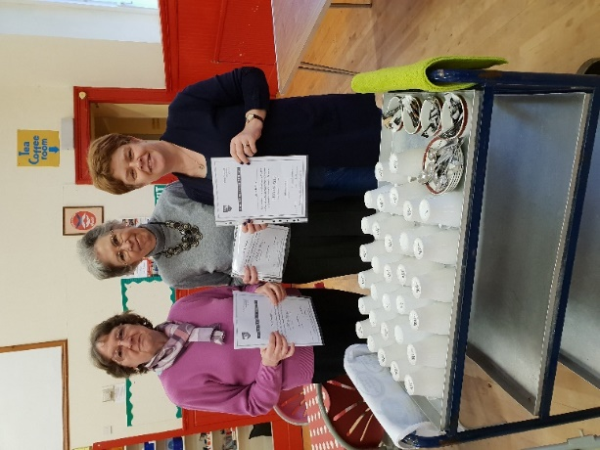
Members of Logie Kirk joined others across the Presbytery of Stirling for Food Hygiene Training. It was important to be refreshed on good practice, but also the provisions regarding allergies and what to look out for.

Pictured here are Hazel Turnbull, Senga Campbell and Alison Gow, three of the team who participated. Other participants were Fiona McBride, Lynne Rennie and
Maggie Roderick.
Afternoon Club
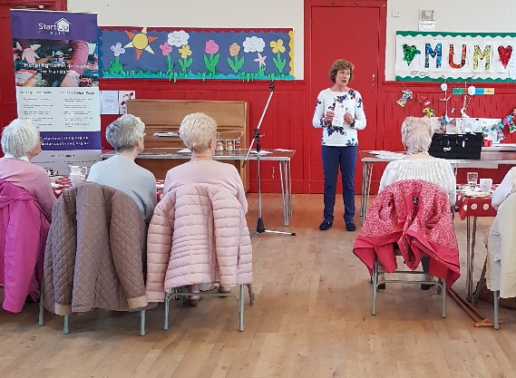
Julie from Start-Up Stirling updating us on changes and new initiatives
Games day
It was great to welcome students
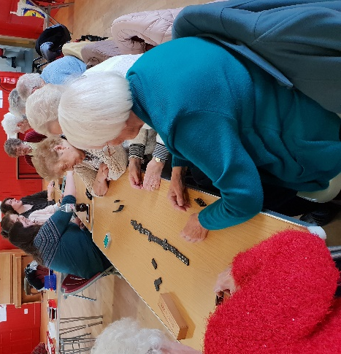

and be served
by our wonderful
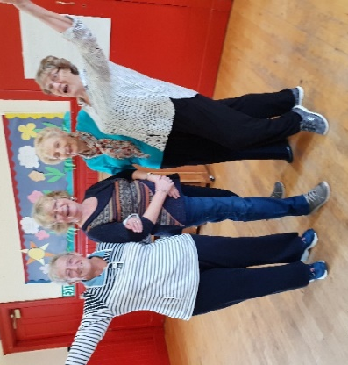
volunteers
The new Wednesday Afternoon activity for the remainder of this year is ‘Bite and Blether’.
Come along for a blether and enjoy tea and cakes 1.30-3.00
All ages are welcome
28th November
12th December
The Guild
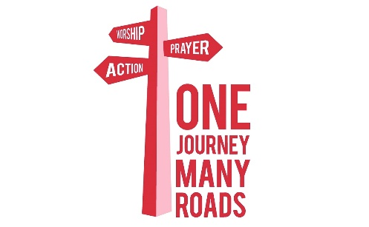
The Guild has met regularly on each 2nd Tuesday evening at the Kirk Halls. Our strategy for the next Three years is ‘One Journey, Many Roads’.

This year we are concentrating on ‘Seeking the Way’.

Our members are invited to commit their lives to Jesus Christ and to be enabled to express our faith in worship, prayer and action. This is reflected in our meetings which start with a short time of Devotions. After that our meetings are varied, with entertainment, speakers or demonstrations from many varying organisations and people. They are always informative and enjoyable.
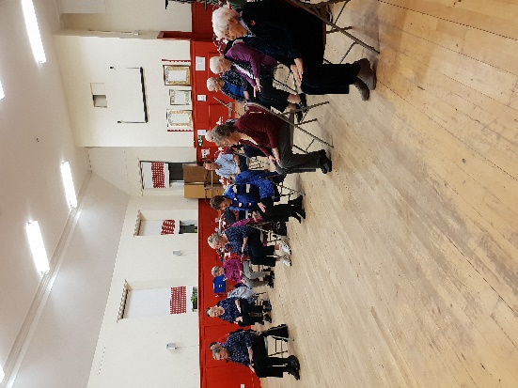
Scene 2 entertaining us with wonderful singing
Gavin Strang from Church of Scotland Church & Society Council

Chair Aerobics with Tricia Chillas

Why not come along and see
for yourself?
The Guild is open to men and women of any age.

Start Up Stirling Christmas Appeal

Start Up Stirling is making an appeal to raise £45,000 in donations to help local homeless people and those in hardship.
Around 30 people receive goods from the foodbank every week in Stirlingshire and this number continues to grow.
Start Up Stirling also provides assistance to individuals and families commencing tenancies after homelessness with their start up packs which provide basic household essentials along with food parcels.
Start Up Stirling is seeking to increase its support services over the coming year to increase assistance in areas such as financial advice, healthy eating and mental health assistance and support.

How you can help
Purchase a donation voucher, perhaps instead of a Christmas present. Donations can be made online at www.startupstirling.org.uk/donate
or directly at the unit at16B Whitehouse Road, Stirling

Start Up needs your help to feed families this winter. If you can help, food donations can be brought to church on any Sunday in
December. Donations of money can be made on line or can be brought to church.

From the organ bench (but not penned during a sermon!)

I remember attending an evening service as a student at a church in St Andrews where the minister had stayed on way past normal retirement age. He began his sermon most remarkably: ‘After 40 years, it is difficult to be fresh …..’. He didn’t intend it as a joke, and his congregation who knew him better didn’t interpret it that way. I found it difficult not to disgrace myself.

I remember also attending my first Watchnight service at Logie a number of years earlier. There was a magic to the lights strung up down the loan – the light shining in the darkness – and the Christmas carol arrangements by David Willcocks with their bell-like quality (that’s ‘bell’ with a small ‘b’ for the benefit of the choir). After 40 years I can say that for me the Watchnight service retains its magic.

It is hard to see David Willcocks’ legacy of Christmas music ever being superseded – it is seemingly timeless. Yet it leaves room for new compositions with contemporary twists.

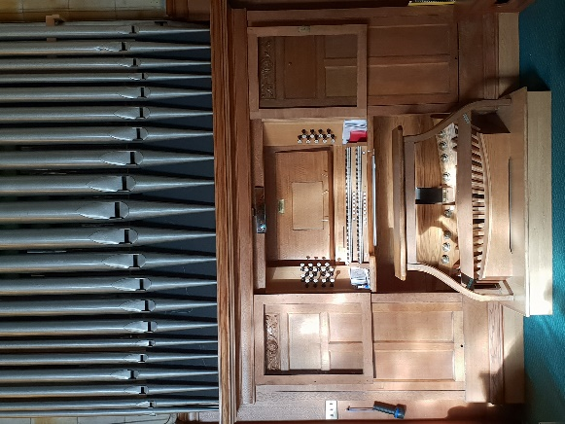
A month or so ago I was given a present of a book of Christmas voluntaries composed and compiled by organists in the Banchory area. It is a fine collection of pieces, and it is impressive that nine different organists within a small radius were able to produce a compilation of such high quality. I shall perhaps highlight them in Orders of Service throughout December, and hope practice time allows me to do them justice.

Perhaps it is this room left for us to participate in our generation and wee corner of the world which preserves the magic and keeps the season fresh.

In one sense, Christmas was a once-and-for-all historical event. Yet the One who came still comes and never stops coming. In the words of the carol:

Still through the cloven skies they come,
With peaceful wings unfurled;
And still their heav’nly music floats
O’er all the weary world.

To cut to the chase, the Choir would be delighted if you would augment their number for our annual Big Sing being held this year on the evening of Sunday 16 December with practices on varied weekdays to suit as many as possible – starting at 7:30pm in the Church Hall on Monday 19 November, Wednesday 28 November and Thursday 6 December, and in the Kirk on Thursday 13 December (it’s not necessary to attend them all). It will be magic to see you there.

Merry Christmas! Alasdair Smith

Weddings

Friday 3 August Jeannie Ogilvie and Darren Macphee
Saturday 11 August Louise Lumsden and George Einchcombe

Baptisms
Sunday 28/10/18 Lachlan Stewart Iain Macphee
Sunday 14/10/18 Georgia Bobbie Stirling
Sunday 9/9/18 Maisy Elizabeth Miller

Confirmed new members
Sunday 28/10/18 Darren Macphee
Sunday 28/10/18 Jeannie Macphee
Sunday 14/10/18 Janice Stirling
Sunday 9/09/18 David Edward Mclean Miller
Sunday 9/09/18 Tracey Miller

Funerals
Monday 18/06/18 Margaret Mary Gardner
Tuesday 28 /08/18 Fred Bastable
Tuesday 4 /09/18 Henry Young
Wednesday 5/09/18 Jennie Marie Merrick
Tuesday 30/10/18 Andrew Buchanan Hendry
Tuesday 20/11/2018 Mary Robertson

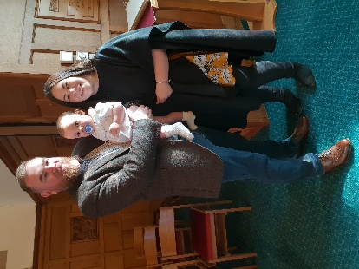

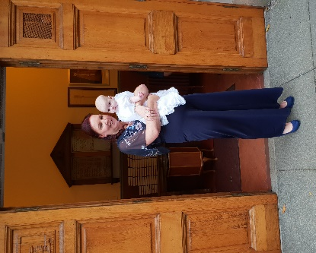
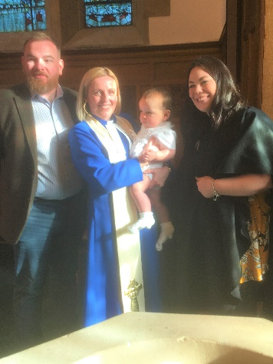

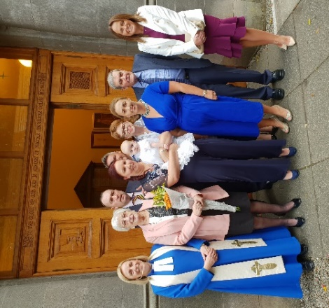

Picture Corner
Top L: Ian Lumsden & daughter Louise
Top R: Louise & George Einchcombe
Middle L: The Macphee family
Middle: Janice & Georgia Stirling
Middle R: The Miller family
Bottom L: The Stirling family
We’ve registered with easyfundraising and we need your help!
easyfundraising is a great website where you can help Logie Kirk raise funds simply by doing your everyday online shopping.
Please sign up and help us at https://www.easyfundraising.org.uk/causes/logiekirk/
It’s easy to do. Once you’ve signed up, when you open the easyfundraising tab, the next time you shop, you access the retailer through this site. Logie Kirk receives a small donation to say ‘thank you’. It’s completely free for you to use, so an easy way to increase our funds without any cost to you.
There are over 3,300 big name retailers like Amazon, Argos, John Lewis, ASOS, Booking.com, eBay, Boden, and M&S.
We want raise as much as possible so please sign up and help us at https://www.easyfundraising.org.uk/causes/logiekirk/

Traidcraft is changing,
but will still exist

Many of you may know that Traidcraft has had a very difficult trading year. At one point, it seemed that the company was set to go into administration. That has now changed.

We will still have a Traidcraft stall at Logie on the second Sunday of each month. The new Traidcraft will be more focussed on grocery items and there will be less craft available. If you would like further information, please contact Maggie Roderick on 07984 604205.

Names and Contacts

Minister: Rev Ruth Halley 01786 463060
rhalley@churchofscotland.org.uk
Session Clerk Team: Graham Eadie 01786 849291
Brenda Smith 01786 834460
Organist: Alasdair Smith 01786 834460
Beadle: June Dunsmore 01786 822868
Treasurer Team: Alastair Innes 01786 822942
Alasdair Smith 01786 834460
Hall Bookings Jackie Taylor 01786 448251
logiehalls@tiscali.co.uk
Editor Dave Roderick 01786 478113
david.roderick2@btinternet.com

@logiekirkstirling

www.logiekirk.org

